Practical No:08
Aim: design and verify the operation of SR flip-flops using logic gates.

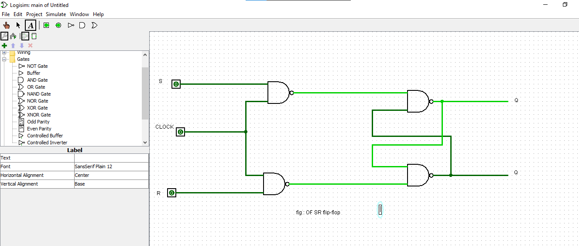

Name: Roshan dhaigude
Sub: Digital System & Architecture
Class:FYBs CS
Roll no:
Sign:

